**POL 201.30 – Introduction to Statistical Methods in Political Science**

**Online Quiz #7 – Solution Key**

| **Total Quiz Score:**   * **13 points.**   Notes:   * For “**Multiple-Choice**” questions with just one correct answer:   + The “🔘” symbol next to a bolded optionrepresents the *correct answer*. |
| --- |

**Section 1**

**Question 1 (1 point)**

**Which of the following best describes the role of the null hypothesis in hypothesis testing for a proportion?**

Question 1. options:

| ⚪ | It assumes the sample proportion is the true population proportion (*0 point)* |
| --- | --- |
| ⚪ | It claims that the sample was biased and not randomly selected (*0 point*) |
| 🔘 | **It specifies a fixed value of the population proportion to test against** (*+1 point*) |
| ⚪ | It adjusts the population proportion based on the sample data (*0 point*) |

| **Justification:** | |
| --- | --- |
|  | **The answer is “It specifies a fixed value of the population proportion to test against”.** Hypothesis testing is used when we want to test whether the observed difference between two proportions is statistically significant. It allows us to determine if there is enough evidence to support a claim about the difference in population proportions. The formulating hypotheses are the Null Hypothesis and Alternative Hypothesis. The null hypothesis assumes no difference between the population proportions. This is done by setting a fixed point to test against. An example would be setting Ho: p = 0.5. 0.5 being the set value and testing for alternative outcomes of p > 0.5 or p < 0.5. In simple terms it is a fixed value that we test our data against to clarify if there is a difference. |

**Question 2 (1 point)**

**What does it mean if your calculated z-statistic falls inside the rejection region?**

Question 2. options:

| 🔘 | **The sample result is significantly different from the null, so you reject the null hypothesis**(*1 point*) |
| --- | --- |
| ⚪ | The null hypothesis is definitely true(*0 point*) |
| ⚪ | You need to collect more data before making a conclusion(*0 point*) |
| ⚪ | The alternative hypothesis is definitely true (*0 point*) |

| **Justification: The answer is “The sample result is significantly different from the null, so you reject the null hypothesis”.** If your calculated z-statistic falls inside the rejection region, it means that the sample data that you used shows that we are unlikely to prove that the null hypothesis is true. This means that a z-statistic falling inside the rejection region indicates that we can reject the null hypothesis because the result is more than likely one of the alternative hypotheses. | |
| --- | --- |
|  |  |

**Section 2**

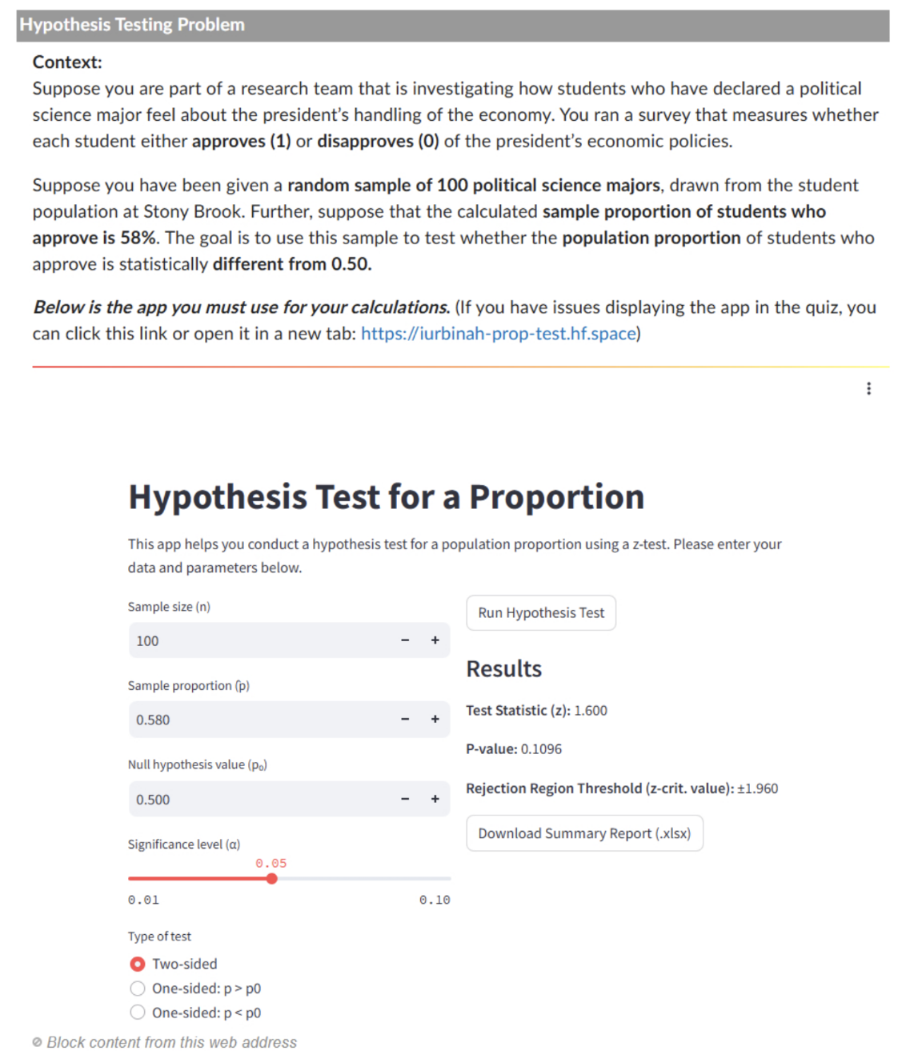

**Question 3 (1 point)**

**Which of the following correctly states the null and alternative hypotheses?**

Question 3 options:

| ⚪ | H0: p = 0.50 HA: p>0.50 (*0 point*) |
| --- | --- |
| 🔘 | **H0: p = 0.50 HA: p ≠ 0.50** (*1 point*) |
| ⚪ | H0: p = 0.50 HA: p <0.50 (*0 point*) |
| ⚪ | H0: p = 0.50 HA: p^ ≠ 0.50(*0 point*) |

| **Justification: The answer is H0: p = 0.50 HA: p ≠ 0.50**. This is the answer because when we are testing to see if our observed difference between two proportions is statistically significant, we set H0 to a value, like 0.50, and HA is any value that is not 0.5, so p ≠ 0.50. This solution can be found on slides 22 and 23 in our presentation on “Inference for Two Proportions”. The H0 indicates the population proportion and HA expresses the difference from the null. So the null is some set value, 0.5 and the alternative is any value other than 0.5, greater or less than. | |
| --- | --- |
|  |  |

**Question 4 (1 point)**

**Which of the following correctly states whether the normal approximation is appropriate as the sampling distribution of the test statistic?** (*Justify your answer with the appropriate calculation in your hand-written work*).

Question 4 options:

| ⚪ | Yes it is appropriate because **p^** is close to 0.50 (*0 point*) |
| --- | --- |
| 🔘 | **Yes it is appropriate because both np0 and n(1-p0) are greater than 15** (*1 point*) |
| ⚪ | No it is not appropriate because we don’t know the standard deviation (*0 point*) |
| ⚪ | No it is not appropriate because the sample size is not greater than 30(*0 point*) |

| **Justification:** | |
| --- | --- |
|  | **The answer is “Yes it is appropriate because both np0 and n(1-p0) are greater than 15”.** The conditions that need to be met for a normal approximation to be appropriate as the sampling distribution of the test statistic is npo ≥ 15 and n(1-p0) ≥ 15. If n = 100 and the p0 is 0.50. The first test np0 is 100*0.500 which equals 50. 50 is higher than 15 so it is appropriate thus far. The second test, n(1-p0) would be 100(1-0.50) which equals 50. 40 is still greater than 15, so the normal approximation is appropriate as the sampling distribution of the test statistic. Being close to 0.50 is not a requirement and the answer is yes, so the third and fourth choices aren’t true. |

**Question 5 (1 point)**

**Using the provided app, compute the test statistic. Which of the following is closest to the correct value of the test statistic?** (*Do not forget to upload a snapshot of the output given by the app at the end of the quiz*).

Question 5. options:

| 🔘 | **z ≈ 1.60** (*1 point*) |
| --- | --- |
| ⚪ | z ≈ 10 (*0 point*) |
| ⚪ | z ≈ 1.96(*0 point*) |
| ⚪ | z ≈ 11.75(*0 point*) |

| **Justification:** | |
| --- | --- |
|  | **The answer is z ≈ 1.60.** Here is the output from the app and how it shows z = 1.60. |

**Question 6 (1 point)**

**Based on your test statistic and the rejection region, what is the correct decision?**

Question 6. options:

| 🔘 | **Reject H0 if |z| > 1.96** (*1 point*) |
| --- | --- |
| ⚪ | Reject H0 if z > 1.645 (*0 point*) |
| ⚪ | Reject H0 if z < -1.645 (*0 point*) |
| ⚪ | Reject H0 if |z| > 2.58 (*0 point*) |

| **Justification:** | |
| --- | --- |
|  | **The answer is Reject H0 if |z| > 1.96.** A two sided test with a significance level of **𝛼 = 0.05**, which equals 5%. If it's two tails, that means 2.5% on each side. The z critical value would be +1.96 and -1.96. |z| means both positive and negative 1.96. We reject H0 when |z| > 1.96 or when it's in the rejection region. |

**Question 7 (1 point)**

**Based on your test statistic and the rejection region, what is the correct decision?**

Question 7. options:

| 🔘 | **Fail to reject H0; there is sufficient evidence that the proportion is different from 0.50**(*1 point*) |
| --- | --- |
| ⚪ | Reject H0; there is sufficient evidence that the proportion is different from 0.50(*0 point*) |
| ⚪ | Reject H0; the sample proportion is numerically different than 0.5(*0 point*) |
| ⚪ | Fail to reject H0; the population is not normal (*0 point*) |

| **Justification:** | |
| --- | --- |
|  | **The answer is “Fail to reject H0; there is sufficient evidence that the proportion is different from 0.50”.** We fail to reject the null hypothesis of H0 because our calculated z test statistic was 1.6. Since 1.6 < 1.96 and 1.6 > -1.96. If it was outside -1.96 < x < 1.96, we could reject it, but we can’t. It’s not in the rejection zone so there is evidence that the proportion is different from 0.50. |

**Question 8 (1 point)**

**Which of the following is the most appropriate conclusion?**

Question 1. options:

| 🔘 | **There is not enough evidence to conclude that the approval rate among political science majors is different from 50%.** (*1 point*) |
| --- | --- |
| ⚪ | The sample shows that 50% of political science majors approve, so no difference exists in the population(*0 point*) |
| ⚪ | There is significant evidence that the approval rate among political science majors is greater than 50%. (*0 point*) |
| ⚪ | Political science majors strongly disapprove of the president's handling of the economy.(*0 point*) |

| **Justification:** | |
| --- | --- |
|  | **The answer is “There is not enough evidence to conclude that the approval rate among political science majors is different from 50%”.** This answer choice is the most appropriate conclusion because since our calculated z-statistic was 1.60, which does not exceed the critical value of ±1.96, we cannot reject the null hypothesis of 0.50 or 50%. There is not enough statistical evidence to be certain there is a difference between our sample proportion and the population proportion. Option 2 is incorrect because our sample proportion was 58%, not 50%. For option 3, we did not find significant evidence. The last claim is disproved because most political science majors, 58% approved. |